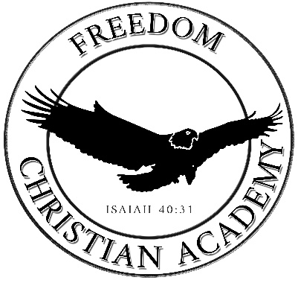

Freedom Christian Academy
2023-2024 Student Calendar

August 8 | Tuesday | Students Report- 1st day of school
September 1  September 4  September 5 | Friday  Monday  Tuesday | Staff Workday (No Students)  Labor Day Holiday (Closed)  Progress Reports Go Home
October 12  October 13  October 16  October 19  October 20 | Thursday  Friday  Monday  Thursday  Friday | End of Quarter 1  Staff Workday (No Students)  Report Cards Go Home  No School- Teacher Conference (Closed)  No School- Teacher Conference (Closed)
November 17  November 20-24 | Friday  Monday- Friday | Progress Reports Go Home  Thanksgiving Break (Closed)
December20  December 21-29 | Wednesday  Thursday | End of Quarter 2  Christmas Break (Closed)
January 2  January 3  January 4  January 15 | Tuesday  Wednesday  Thursday  Monday | Staff Workday (No Students)  Staff Workday (No Students)  Classes Resume / Report Cards Go Home  Martin Luther King Jr. Day (Closed)
February 5  February 19 | Monday  Monday | Progress Reports Go Home  Presidents’ Day (Closed)
March 7  March 8  March 11-15  March 18  March 29 | Thursday  Friday  Monday-Friday  Monday  Friday | End of Quarter 3  Staff Workday (No Students)  Spring Break (Closed)  Classes Resume / Report Cards Go Home  Good Friday (Closed)
April 15-19  April 22 | Monday-Friday  Monday | School Wide Testing  Progress Reports Go Home
May 24 | Friday | Students’ Last Day of School- Early Release / Report Cards Go Home
 |  | *Storm days are to be determined as needed.

Rev 5/31/2023- 180 day calendar- student

